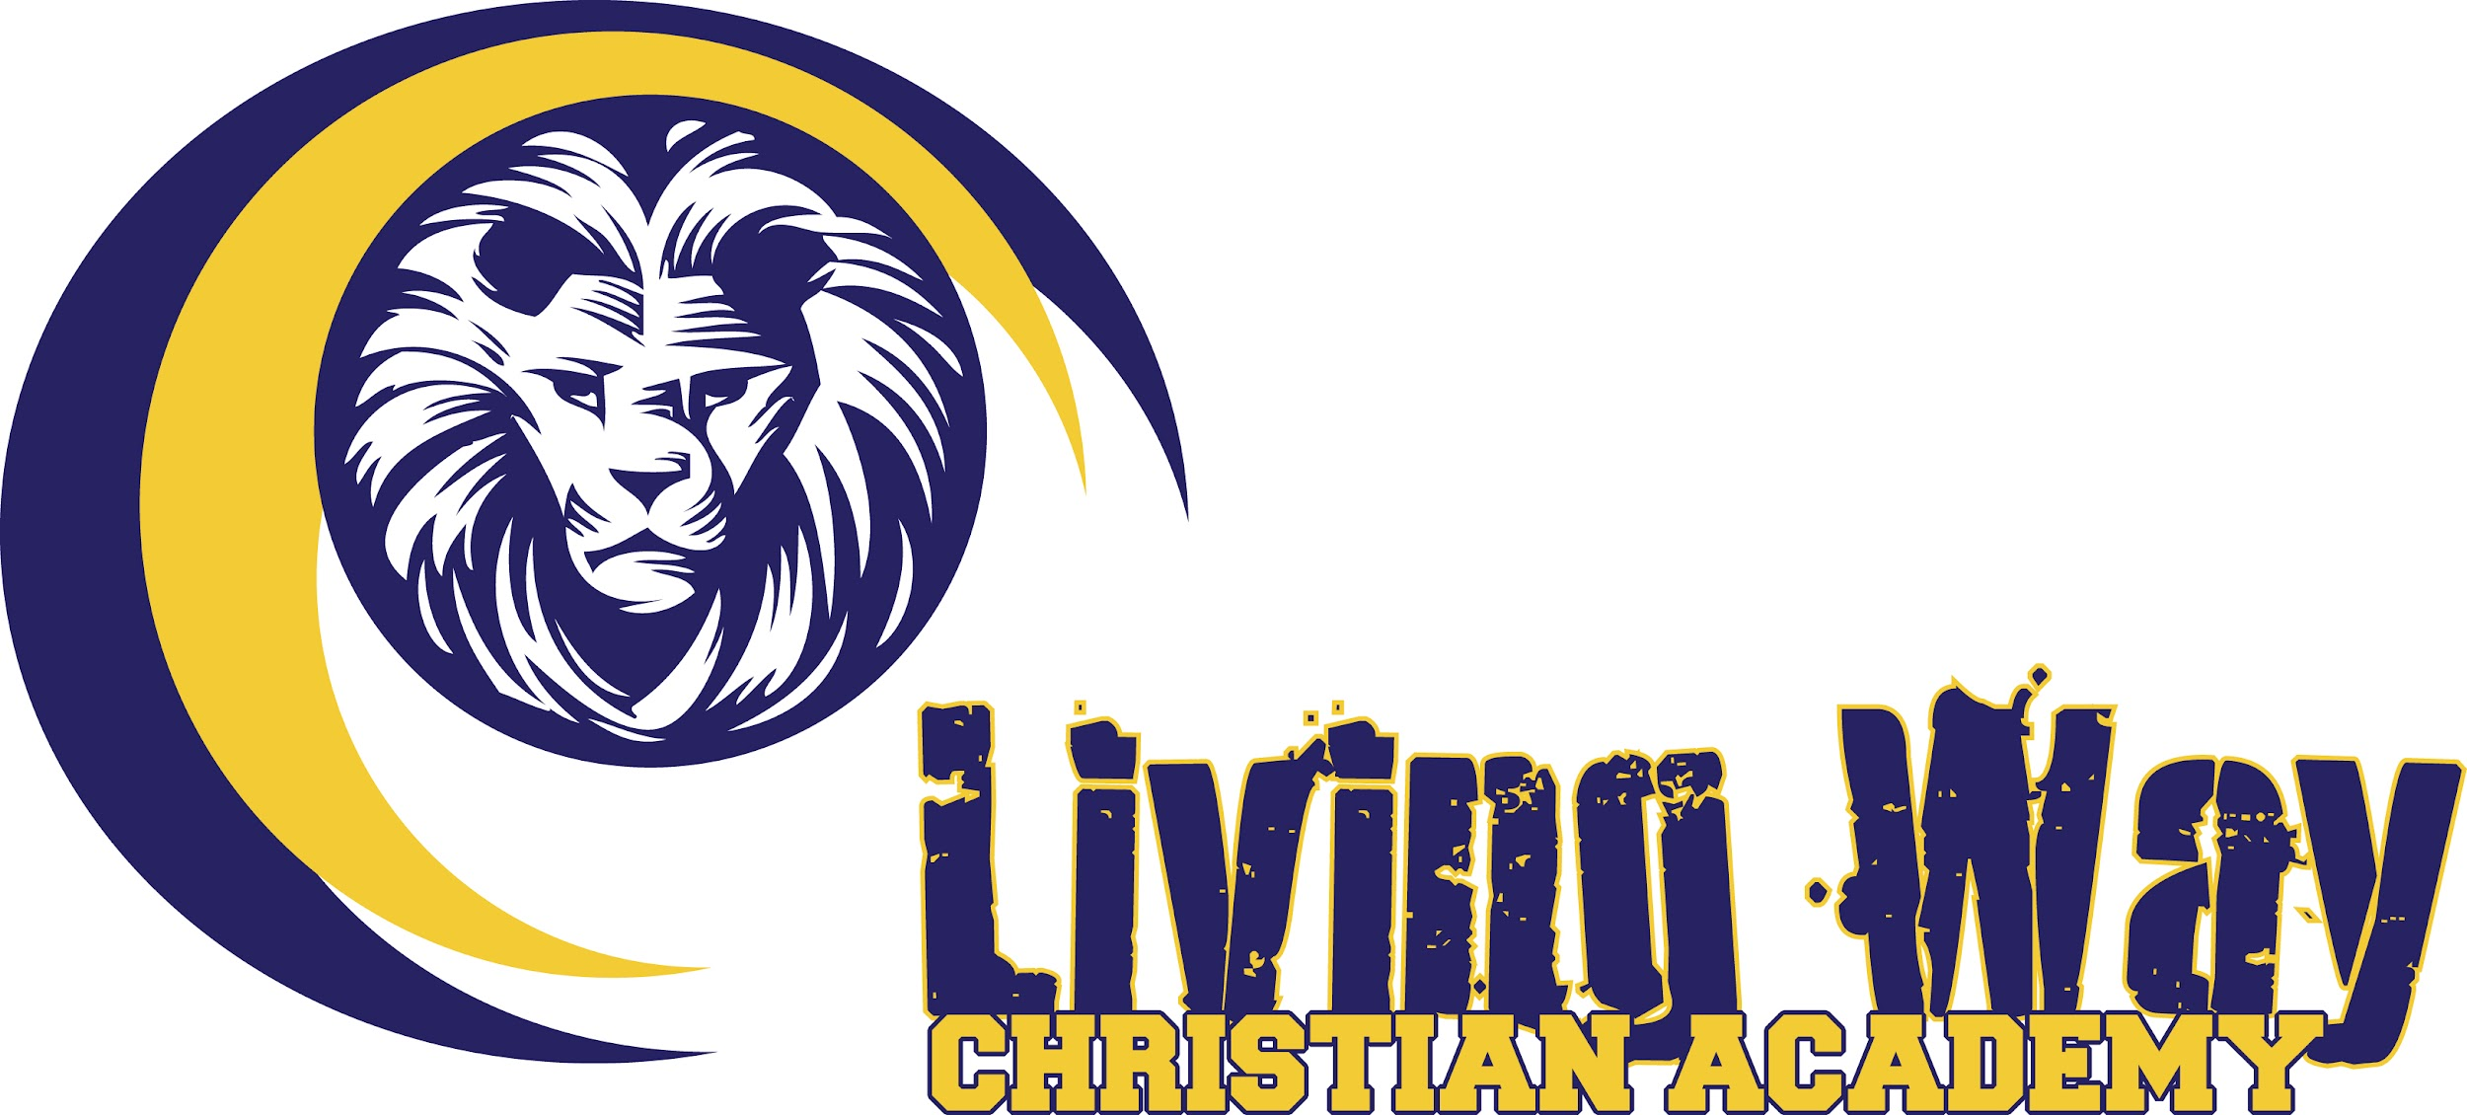

2024-2025 School Calendar

***Fall Semester***

July 31 Curriculum Fees Due

August 19 Parent Orientation/Open House

August 20 First Day Of School

Sept. 2 Labor Day

Oct. 4-6 Great Locomotive Festival Fundraiser

Oct. 18 End of First Quarter

Oct. 7-11 Fall Break

Nov. 21 Thanksgiving Lunch/Early Release

Nov. 25-29 Thanksgiving Break

Dec. 19 Christmas Party/Early Release

Dec. 23-Jan. 3 Christmas Break

***Spring Semester***

Jan 6 Assignments Resume

Jan 7 First Day Back On Campus

Jan 10 End Of 2nd Quarter

Jan. 20 MLK Day (no school)

Feb. 17-21 Winter Break

March 21-23 Jr High Retreat

March 21 End Of Third Quarter

March 18-19 Standardized Testing

April 3-6 High School retreat

April 7-11 Spring Break

May 20-21 Spirit Days

May 22 Awards Ceremony/Last Day Of Assignments

May 24 Graduation

May 26-June 10 Finish Up Weeks

*Field trips will be scheduled throughout the year. You will be notified prior to each trip.

*Some dates may be subject to change.